# The University of Memphis

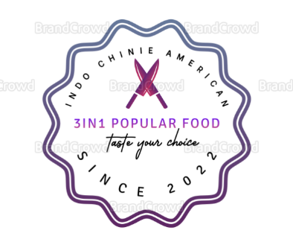

**3IN1 Popular Food**

<https://3in1popularfood.wordpress.com>

**MIS 7710 Fall 2022**

Web Analytics for Business

Instructor: Scott W Vann

Date:12/01/2022

**Group 2 Members**

Sushmitha Thogaranahally Nagaraju

Hong Shi

Juliet A Onyando

**Abstract**

Our business is a start-up restaurant website that provides three countries’ popular food in one place. We provide Indian, Chinese, and American popular cuisine in one place. On this website, customers can choose a variety of food, and order breakfast, lunch, dinner, and desserts. This website gives you options to reserve a table and pre-order for dine-in, Online Order for delivery, or to-go and book a restaurant for their special occasions. This system allows customers to modify the existing order or choose delivery for up to the next day. Customers can also customize orders to their choice. We also provide ingredients for each item on the menu and provide safety measures we have taken.

Currently, we started in Memphis, and we make it more comfortable for friends, family, colleagues, and guests who want to eat different cuisines in one place. We want to provide our customers with authentic traditional unique dishes. Once the food is delivered, our website asks for feedback and ratings for that order in that way we continuously improve from customer feedback. We also provide refunds if that order is misplaced, or the customer is not satisfied. You can track your order or pre-book your order to save wait time. If we can’t deliver within the predicted time, we deliver our food freely! We also have a chat board with customer care which works 24/7. We aim to provide extraordinary customer service.

We proposed this business from our experience, we have a group of friends from different places, and we could not be able to find a common restaurant where we could be able to order or go and eat our favorite food, and online services were also not up to the mark, so we decided to open this new website for 3 in 1 restaurant serving for majority of communities in Memphis.

# **Company Goal**

Our short time goal is to provide excellent customer service, providing healthy, fresh, authentic, and customized food to satisfy customers. And our long-term goal is to make all community friends, family, guests, and colleagues get their favorite dish in one single place without adjustment. We would like to expand our business all over the country.

# **How Different We Are**

We provide all 3 countries’ food in one place in Memphis. As we know no restaurant has provided it till now, so we have a unique business with more advantages for the customer. They can order online. We provide an estimated delivery time if we can’t deliver that order within the predicted time, we give that order free of cost. We provide healthy, customized food. It may be online or dining in our way of cooking will be the same. You can also do pre-orders before the day we deliver the food within that time. We provide excellent services to customers which makes customers happier and more time-saving.

# **Domain**

Three in One is a restaurant designed to have a unique variety of foods. Therefore, the chosen domain name is to support the title of the restaurant.

[3in1popularfood.wordpress.com](http://threeinonepopularfood.com)

# **Target Customers**

The target customers are those in the Memphis area who are excited to have different food varieties that are not traditionally found in the south. Our target customers are 20 to 35 who have traveled outside the United States or wish to do so. People who work in corporate roles and tend to eat out for lunch are another target customer.

# **Marketing Strategies**

Based on the target customer, marking is designed around local influences on social media, paid web ads, and traditional marking. Local influencers who travel a lot will be invited to the restaurant to enjoy discounted food in exchange for a social media post. The target influencer will be someone who has an active following and regularly posts. The goal of the post is for the influencer to share how the food reminds them of an experience while traveling.

Paid web ads will be placed on cooking blogs when users search for the cuisine they are trying to cook. We must set the parameters via zip code, city, and dish name.

Lastly, traditional advertising will take place at Memphis Airport. The airport receives thousands of visitors coming to Memphis. This will allow us to reach broader customers who are not active on social media and are interested in trying different cuisines.

# **Competitors**

## India Palace:

India Palace is a premium Indian Restaurant that has been proudly serving the Memphis area and beyond since 1995. Their mission has been to provide high-quality food for all those that wish to combine fun and enjoyable ambiance with skillful cooking into one extraordinary dining experience. This is according to their website Their focus is Freshness and creativity as they called it favorite ingredients. Their Menu is varied, as they offer a variety of culinary for those looking for a superb culinary experience

[**https://www.indiapalacememphis.com/**](https://www.indiapalacememphis.com/)

## Curry Bowl:

"Curry Bowl" is Indian Cuisine, family owned and operated, located in Memphis, Tennessee They comprehend and make progress towards social taste and assorted variety. They offer every day full smorgasbord among 100 Indian dishes according to their website. In this way, the ordinary is diverse with various dishes and an authentic yet inventive eatery with a menu. They focus on the assortment of flavors. A visit to Curry Bowl is a culinary voyage to find the extraordinary taste and texture of Indian Cuisine.

Their strength lies in all dishes served, using only the freshest ingredients and authentic recipes. Whether you are a fan of vegetarian cuisine or Indian food in general, you will enjoy their flavorful dishes. They not only provide dining services but also catering services. Experience the finest Indian cuisine at Curry Bowl.

[**https://www.currybowlindiancuisine.com/about.php**](https://www.currybowlindiancuisine.com/about.php)

## Mulan Asian Bistro:

Mulan Asian Bistro is a Chinese cuisine restaurant with three locations in Memphis, Tennessee. At Mulan Asian Bistro, you will mostly find Sichuan dishes (one of the eight major Chinese cuisines) and sushi dishes. It is Mulan's constant endeavor to come up with new dishes and post them on their social media platforms. Mulan opened a pop tea bar inside its Collierville location recently. Mulan offers not only delicious food but also entertainment, such as karaoke and dancing. Mulan offers its customers pleasant leisure time.

[**https://mulanbistro.net/**](https://mulanbistro.net/)

## Huey’s:

Huey's serves American cuisine. In April of 1970, Huey's was founded by a local Memphis, Allen Gary, at a midtown location. Currently, there are nine locations in the Memphis area. Their business philosophy is to provide the best food, the best service, and the best atmosphere. Famous American foods are served in Hey's, including burgers, sandwiches, salads, and fried chicken wings. Huey's is one of the most famous and historical American restaurants in Memphis. Travelers and loyal customers frequent the place.

One of their strengths is that they serve customers a variety of American food items, and the interiors are decorated with a sense of history. Hey’s become the one place the visitor would like to visit in Memphis. One weakness of them is that the time waiting for a table is too long.

<https://hueyburger.com/>

# **SWOT Analysis**

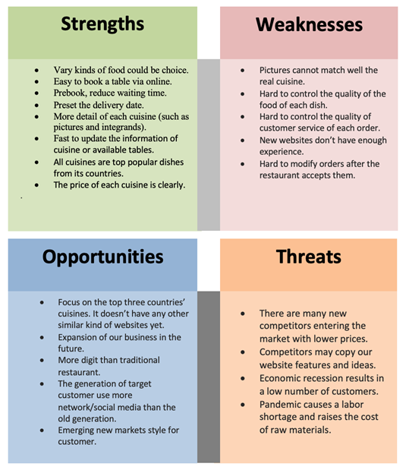

# **Business Strategy**

The first step in our business strategy is to build an online website at <https://3in1popularfood.wordpress.com/images/>.

WordPress will be used to build our site. Our social media presence will launch on Instagram, Facebook, Twitter, and TikTok. To attract and keep in touch with our followers, we will post our restaurant's dishes and any updates on these platforms. We will keep posting 3-5 times each day and use the 15-25 most relevant keywords as our hashtags for each posting through our social media. We will offer each follower a 10% discount on the entire receipt when they come to our restaurant to eat.

While the website is developing, we will choose a suitable location to open our restaurant. We will choose to place our advertisements in airports, local shopping malls, and stations to attract target customers. At certain times, we will offer a limited number of special dishes with an additional discount in our restaurant.

To attract more customers, we are considering offering a 10% discount for their return orders which are non-followers. To get more loyal customers, we are considering making a cumulative points system for our customers. When they spend $1, then they can make 1 point. For every 500 points, you can exchange a free dish (under the limited price of these dishes). This will lead them to come back to our restaurant to get the excluded reward for them.

We plan to build brand recognition by.

* Design our exclusive logo which is simple and easy to remember for our business.
* Put the logo on bags, napkins, tables, packing boxes, menus, employee uniforms, and walls for our restaurant.
* Launching an Email and Search Engine Marketing campaign using Google Ad Words and Mailchimp to target new viewers and increase traffic to our site.
* Launching Every Door Direct Mail to send our restaurant opening information, and marketing activities.

During this process, we will catch our target customers immediately and evaluate whether we've succeeded or failed after one month of our restaurant's opening. And we will adjust our strategies accordingly.

Instagram:<https://instagram.com/3in1popularfood?igshid=YmMyMTA2M2Y=>

# **SMART Web Analytics Measurement Framework**

|  |  |  |  |
| --- | --- | --- | --- |
| **Business Objective** | **Goal** | **KPI** | **KPI Target** |
| Sell dishes and Beverage | Sell more dishes | Weekly revenue | 10000 per day |
| Sell more beverage | Weekly revenue | 1000 per day |
| Increase service quality | Decrease average waiting table time | Decreased 5 mins |
| Increase the speed of dishes delivery | Increased 5 mins |
| Make more profit | Profit margin | 10% |
| Effective Online Marketing | Increase website visits | Attract more new visitors | Attract 50 new visitors per month |
| Increase more followers on our social media | Increase the number of followers | Adds 500 followers per week |
| convert more visitors to customers | Attract visitors to stay more time, eg:1min-2mins | Increase online orders to 15 per month |
| Build restaurant brand in local & online | Increase the rank in the industry | Increase the rank | Increase one rank, or keep, don’t decrease it. |
| Attract more Memphians | Attract more local target customers | 35 new local customers per month |
| Increase loyalty  members | Increase the return customers who purchased | 10 return customers per month |

# **Web Design**

Please see our website at [[https://3in1popularfood.wordpress.com](sush%20part.docx)](https://3in1popularfood.wordpress.com)

# **Logo**

We used FreeLogoDesign.org to create our logo. It has our business name – 3IN1 Popular Food, the tagline “Taste your choice”, the name of the country food we are serving, and a year of origin. A colorful circle with drawings of kitchen knives is our indication and the theme font we have used is Calibri with size 11. The meaning behind the tagline is that whatever the choice made by the customer, they can taste it as they expected in our restaurant. It is our first franchise in Memphis that started in the year 2022. The mixed color is the indication of refreshment, growth, health, and teamwork of our restaurant employees.

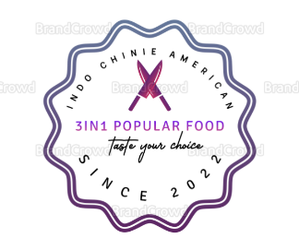

# **Other Design Details**

We have created a website using wordpress.com without upgrading any features. It was a real challenge for us to show aesthetically good, with all the proper information on the page, but without any plugins added it was slightly difficult. We wanted to keep our theme aesthetically good, with food pictures so we selected the “Rockfield theme”.

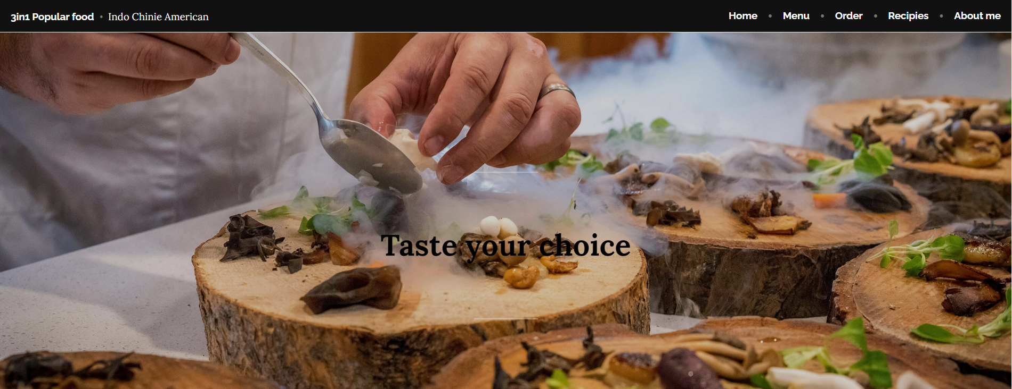

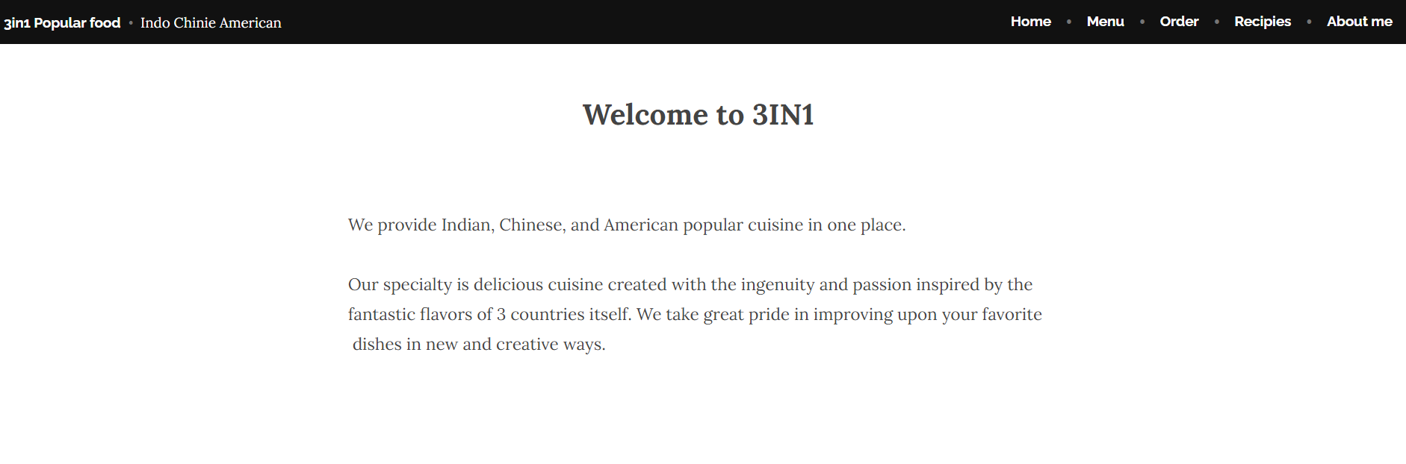

We kept our home page toolbar in black to highlight our tools and theme Calibri with a size of 11. We have a home, menu, order, Recipes, and about the restaurant. In the left corner, it shows our business name “3in1 popular food” with the three country names “Indo Chinie American”. As soon as the first glance at the page if we scroll down, we can see the welcome page and a small introduction to the restaurant. We have used a white background and black letters for a more elegant look. We hope that this direct and brief conduction will capture the interest of visitors.

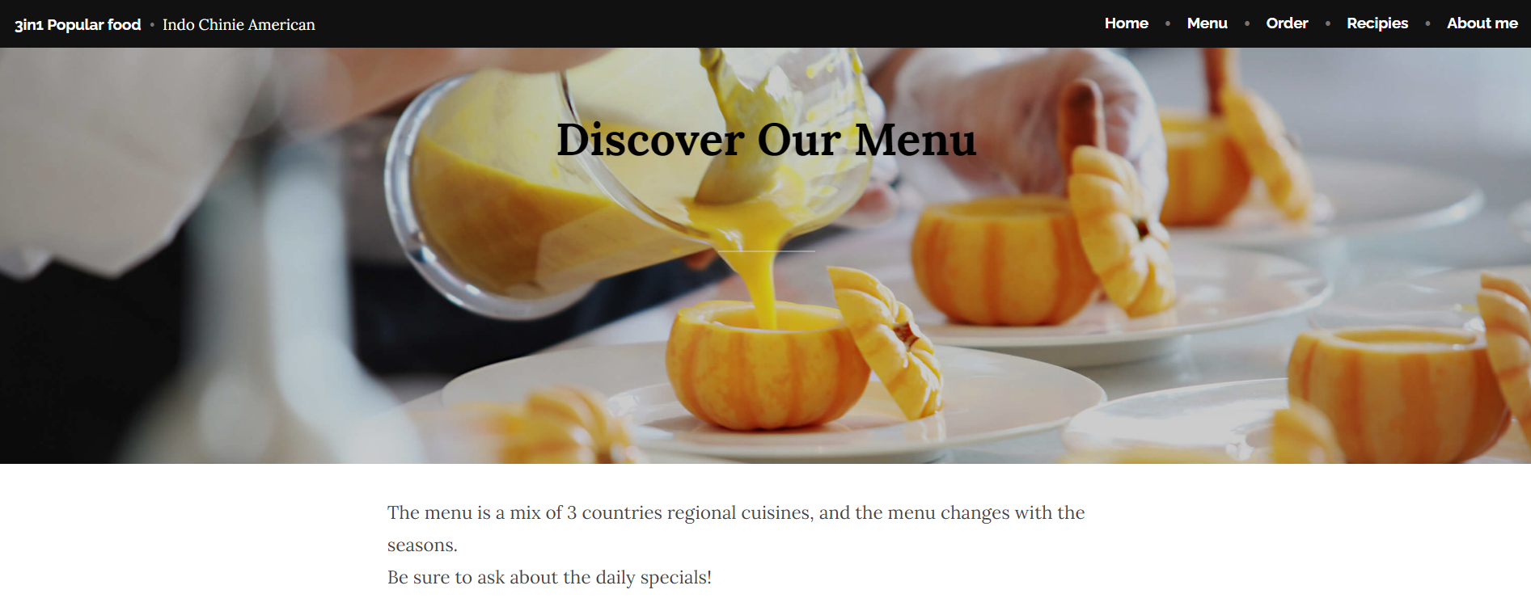

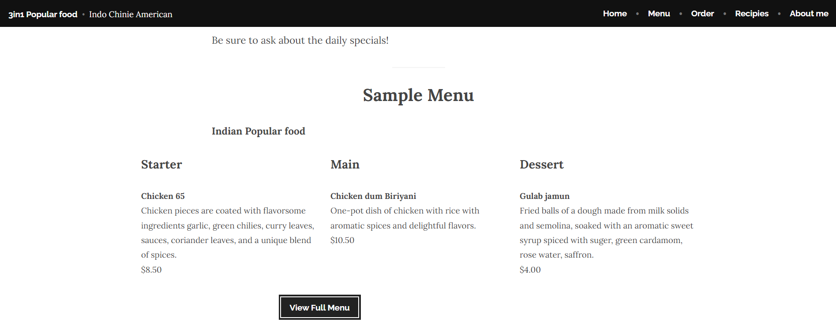

On the same home page after the welcome page, we have added a beautiful background picture with the bold letter “Discover our menu”. A small taste of the menu with a white background. We want to be transparent with the customers about the price of the food. And our food menu changes with the seasons. We do have a daily special. On the same home page, we have a sample menu of Indian popular food with a small description and price. If we click on the button to view the menu it will take us to the menu page.

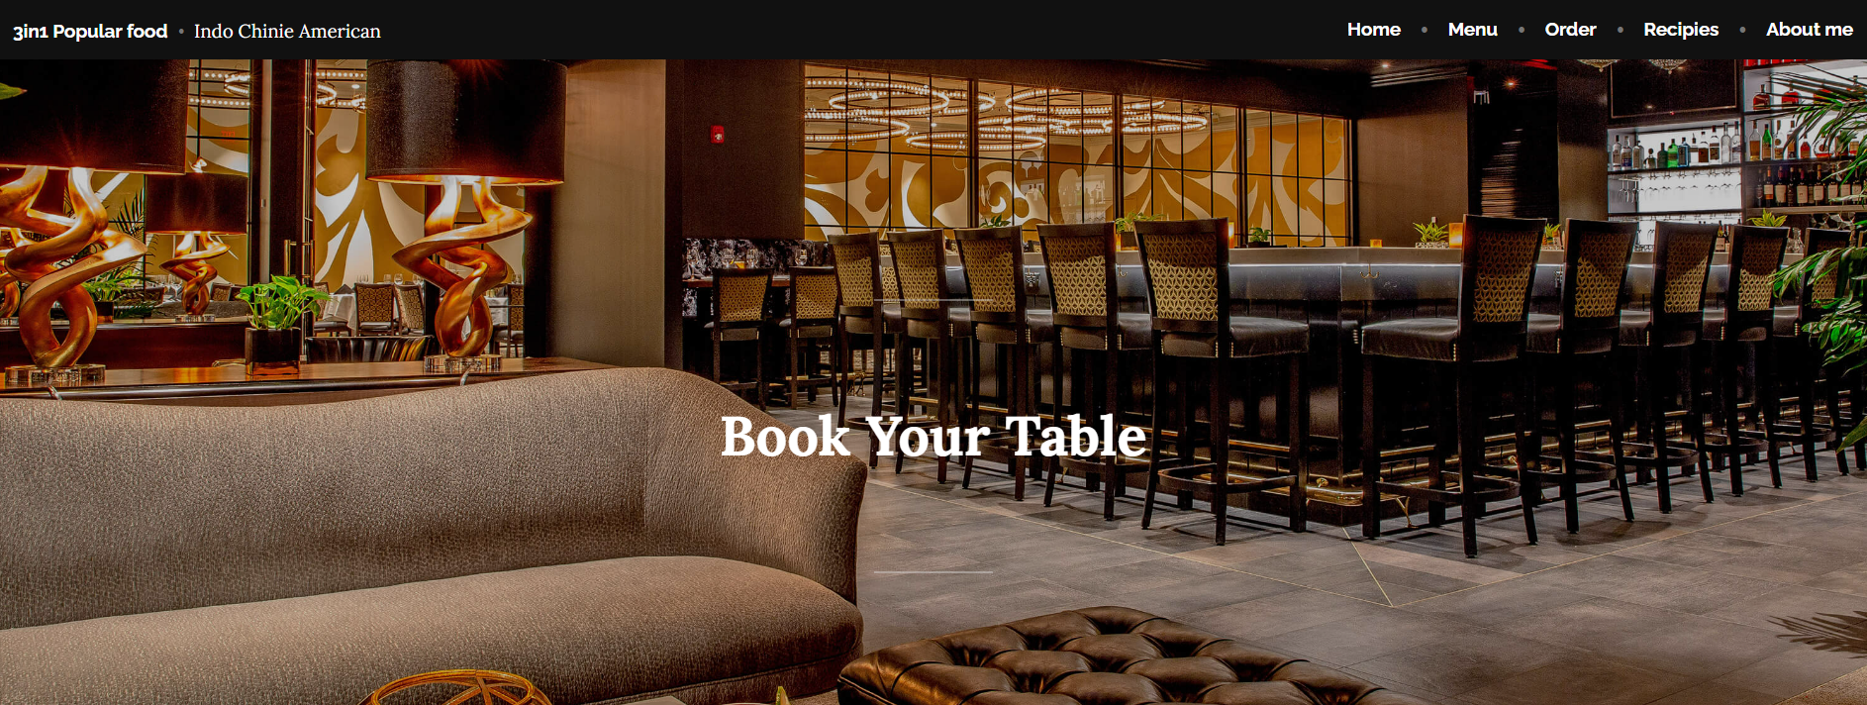

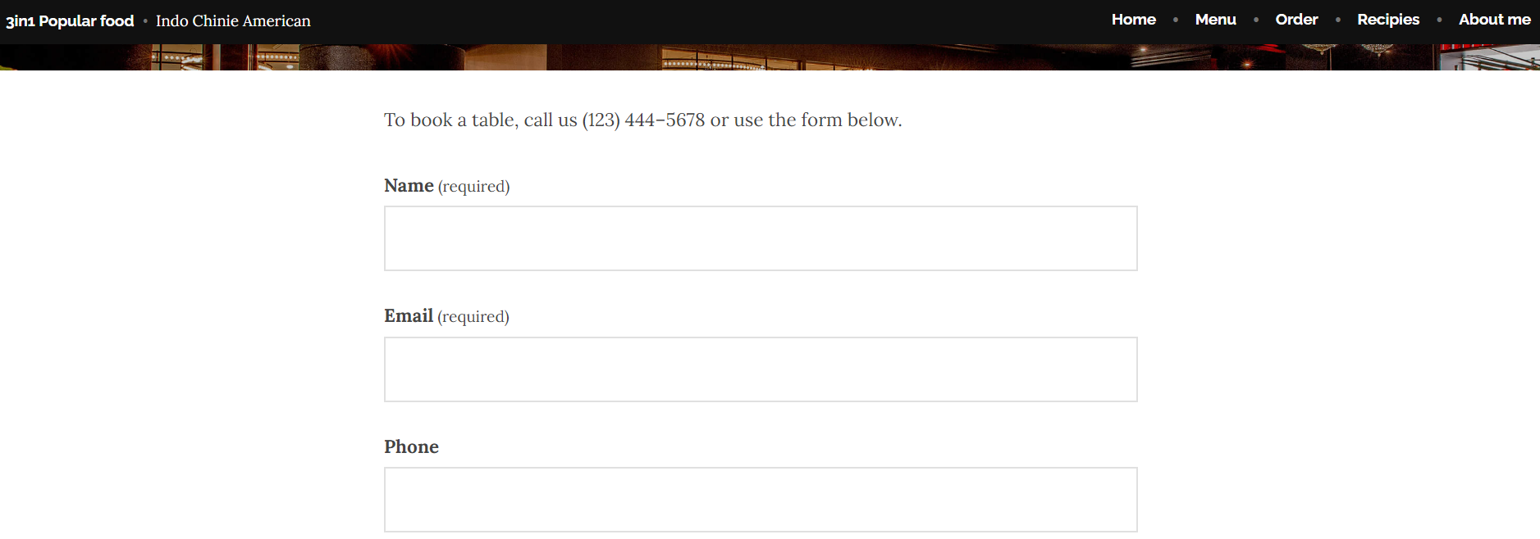

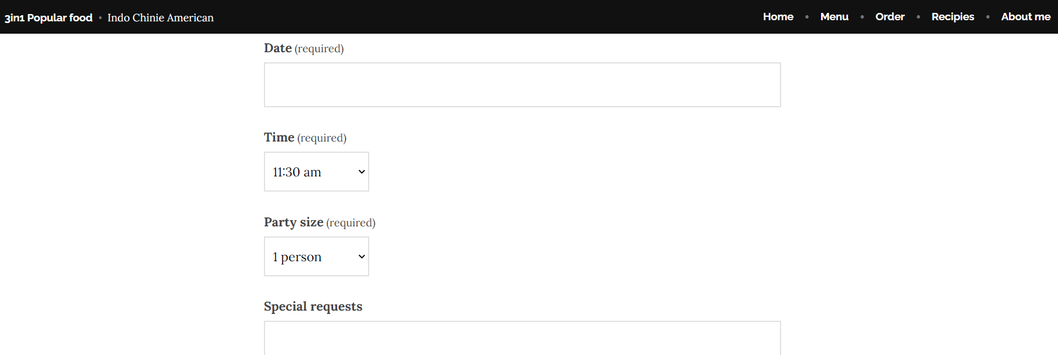

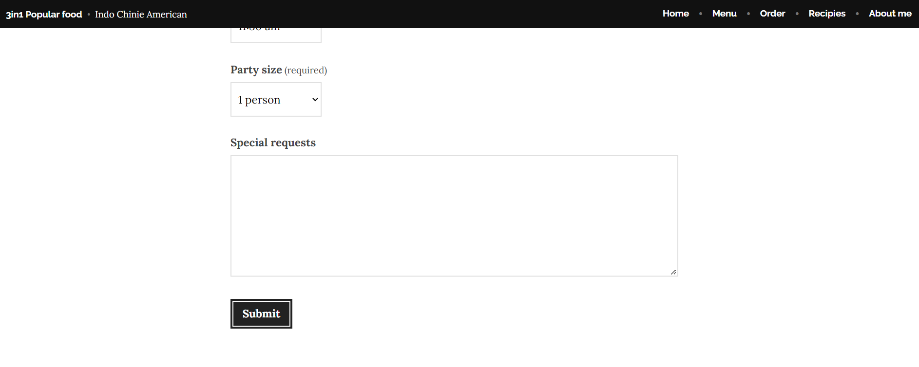

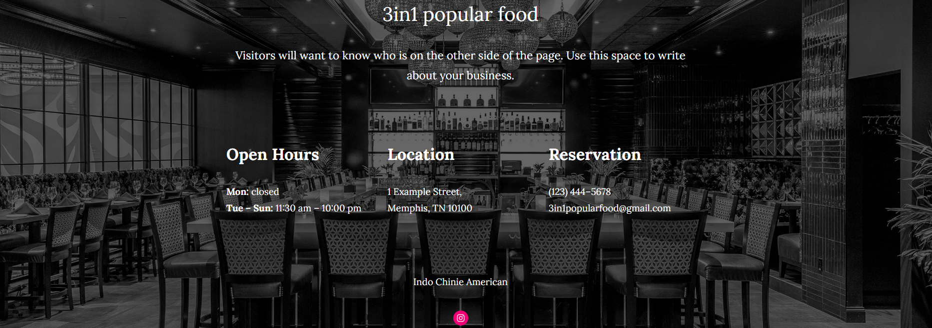

Customers can book the table in advance, so we have been given the option to book the table and we have asked for prior information on the home page. Name, Email, phone, date, time, party size, and special requirements, or requests. (Required) options are mandatory to book a table. Our website will send a notification to customers by mail, or phone about the booking confirmation. And our website gives the option to call and book the table prior to the appointment. One of our employees will answer the phone and book the appointment for the customer. We have given the information about opening hours, holidays, location, and contact number. Users should not find any difficulties while using our web page, we are on social media please like and follow us on our Instagram page <https://instagram.com/3in1popularfood?igshid=YmMyMTA2M2Y=>.

We believe our website home page has simple and fresh visuals, in line with people's pursuit of a minimalist lifestyle nowadays. We chose the picture displayed on the homepage because we not only want to convey the deliciousness of food and the fun of cooking, but we also want to encourage people to enjoy their meals with friends or family, as well as appreciate social time and healthy meals.

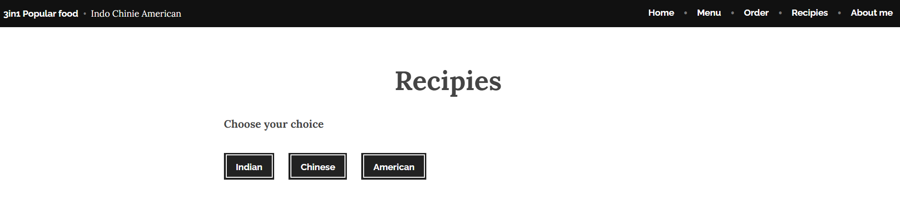

At the top of our website, people can click on the subsite they want to browse. "Recipes" are The most important parts of our web. We have given the 3 categories in the recipe’s subsite Indian, Chinese, and American Users can choose the categories according to their needs. We have added a button in black with white letters, all the descriptions are in Calibri of 11-size theme text.

If users click the Indian button the link takes them to explore Indian popular food.

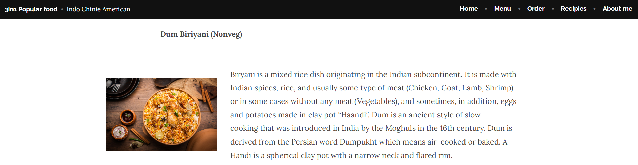

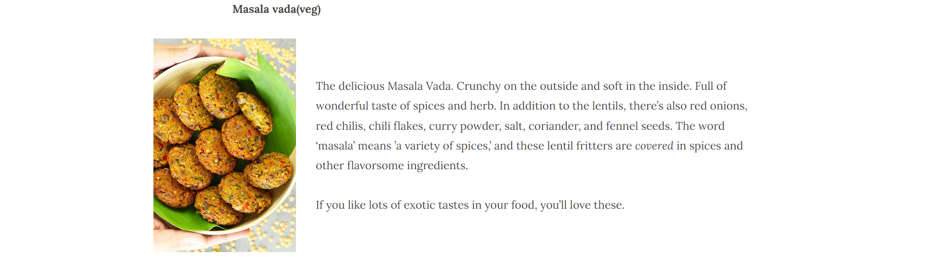

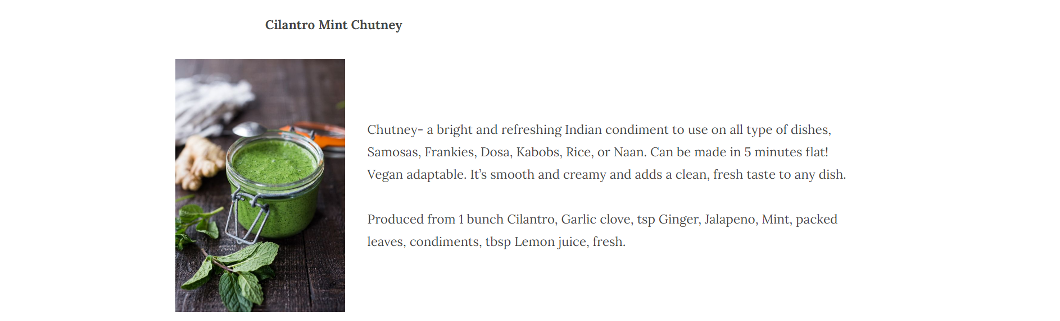

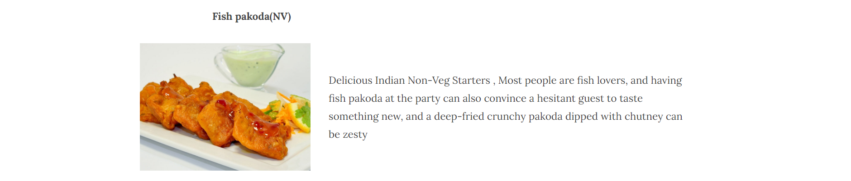

Users can explore more Indian, Chinese, and American popular cuisine here, with all descriptions of how it is made, and what ingredients are used. And summarize the features of the food with one or two short sentences to attract visitors to click in and explore more.

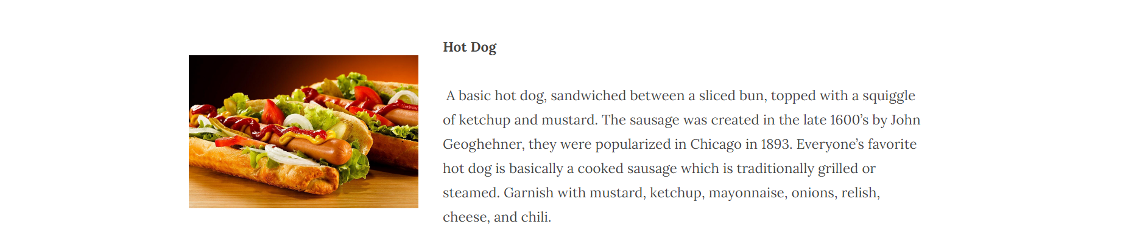

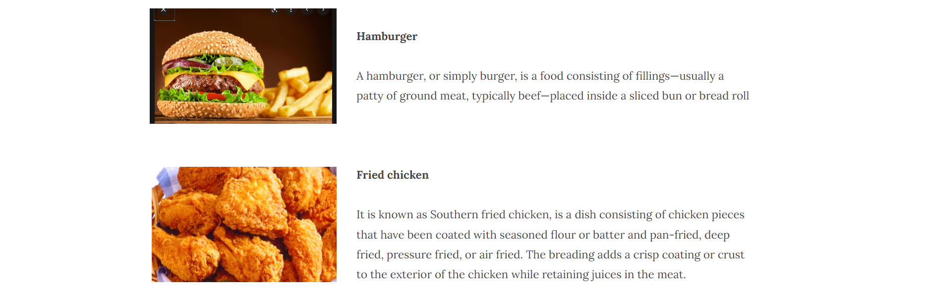



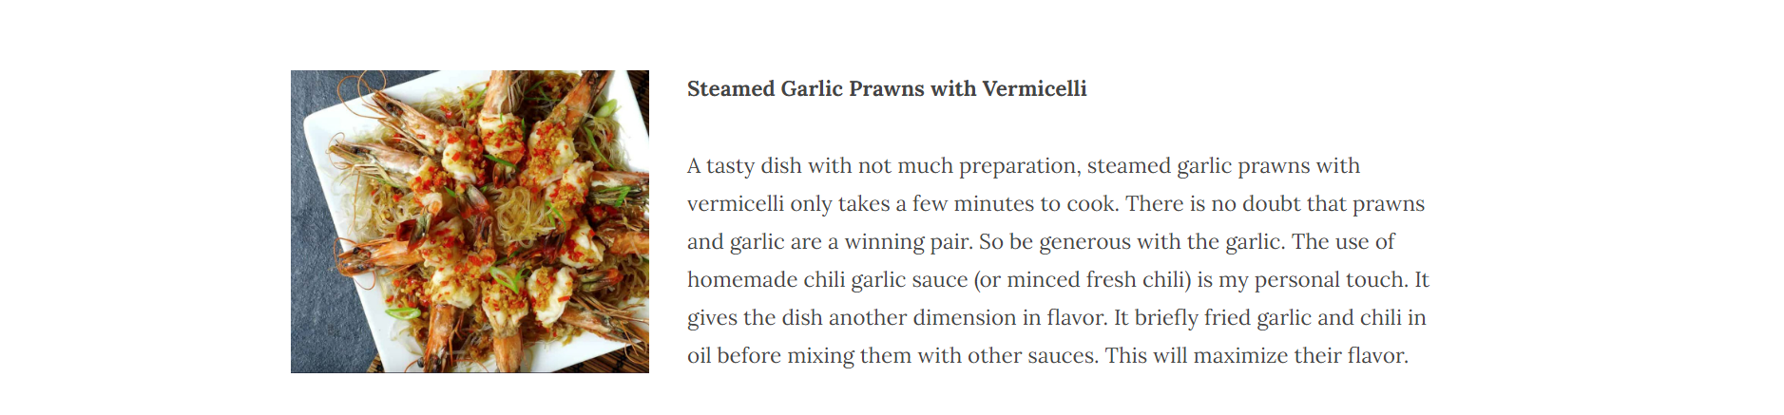

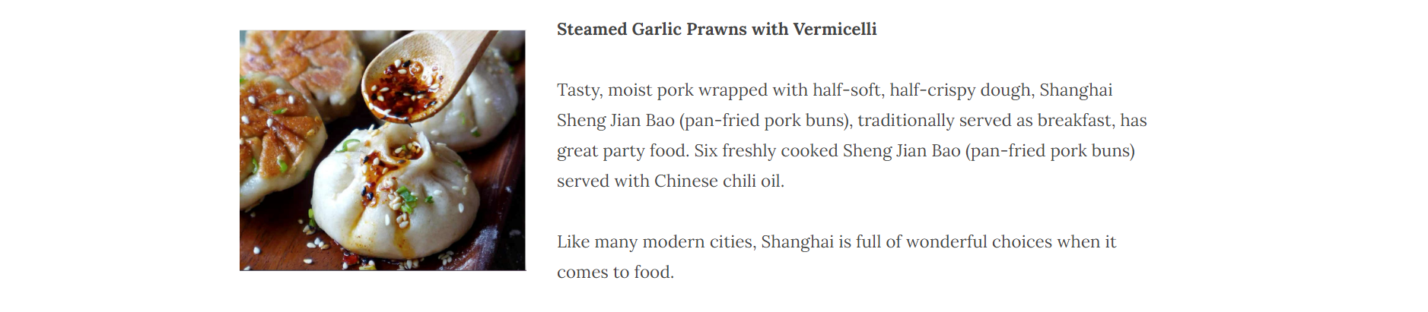

Likewise, on the recipes page of our website users can read the description of ingredients, how it is made off, and photos of the dish, which helps them to imagine the dish with the description.

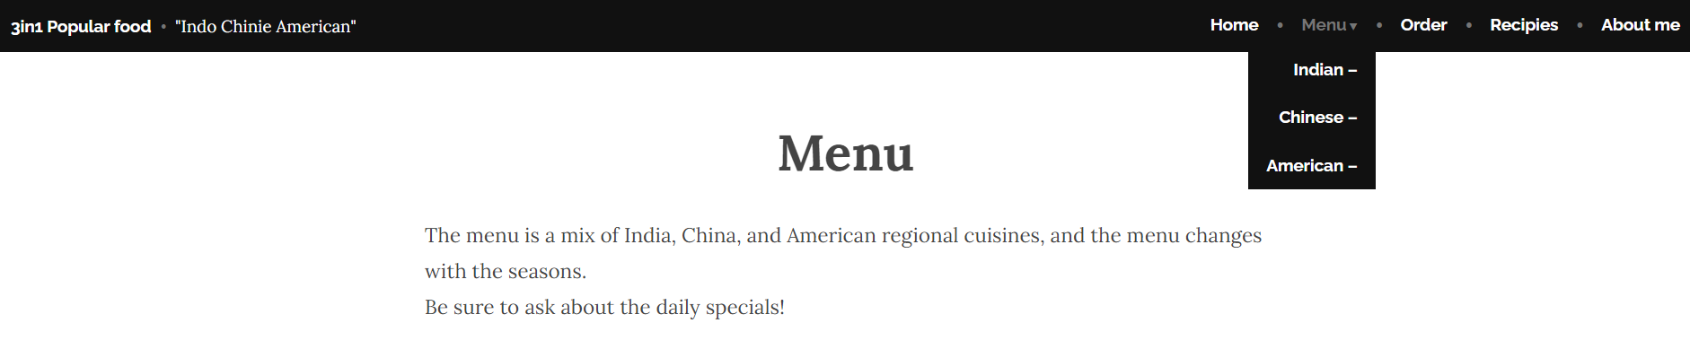

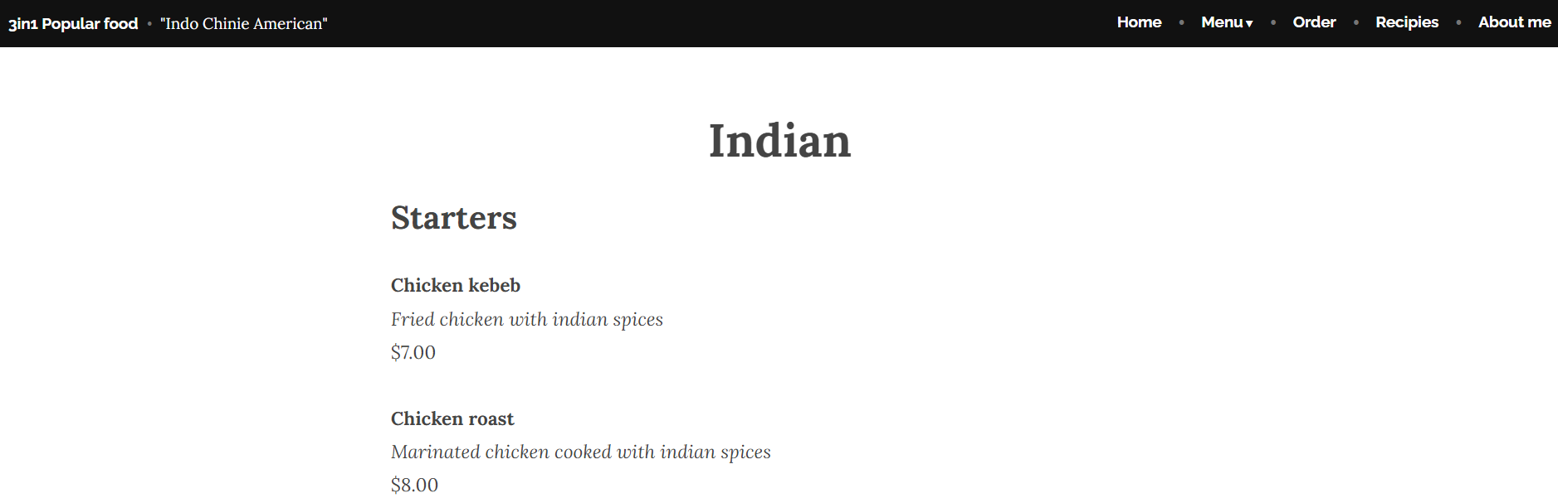

We have a child page for menus in Indian, Chinese, and American. Users can select any country to see the menu. It included the price, name, and a short description of the dish. We have a starter, main, and desserts with the prices below. Italic text and size 10 theme texts are used to describe cuisine. We have not used any plugins, as we must work on a free service, we are doing our best to create this popular food website.

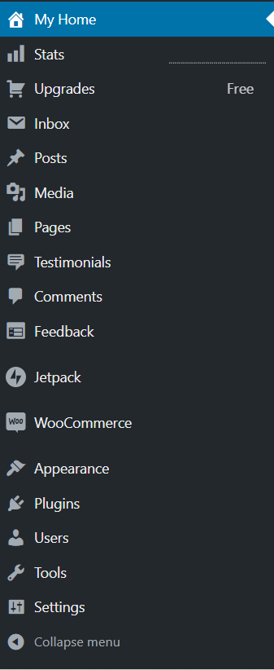

# **Search Engine Optimization (SEO)**

# **Keyword Research**

When people want to search for something, they usually choose the most relevant word or a couple of words to search for, which is called a keyword. Therefore, if our website wants to get more organic traffic, we must set up our keywords so that they can serve the website and users better and more efficiently.

We utilize Google Ads Keyword Planner to conduct our keyword research.

# **Our Keyword Research Goal**

We use Google Ads Keyword Planner to generate the most 10 keywords in high search volume, relevant in our content, low in competition and at least one is longtail. We put these keywords on the relevant pages of our websites to help the target audience search our website effectively and help our website get more organic traffic.

# **SEO Strategy**

To get the maximum amount of organic traffic on our website, we plan to follow the SEO strategy below:

* OnIn the home page or the relevant pages of our website, increasingly use these 10 keywords which we picked up, to help the engine to catch them efficiently.
* Use these keywords in the exact right place to help visitors to get the information that they need to convert these visitors to our customers.
* When we publish a new piece of content on our website, we will use some internal links to link back to the old relevant pages of our website.
* To grab a high volume of organic traffic to our website, we need to write high-quality content including these highly relevant keywords.
* We plan to use some keywords in our website page URLs if it is possible.
* Making our website more suitable for phone outperforming, to attract visitors who use phones to search for information.

# **Applied Keywords**

Below is the list of keywords selected for our website:

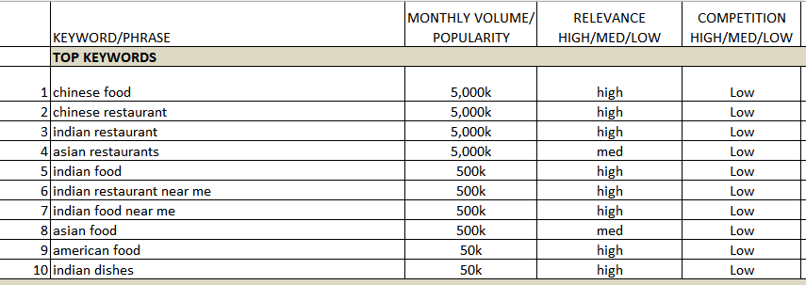

# **Social Media Strategy**

We installed a social media plugin on our WordPress site to have a social media icon appear on our website. The icon allows our website to connect with social media pages to generate traffic to the website.

Social Media acting as a marketing tool has enabled us to put our focus on using the platform strategically to connect with our audience to help build our brand and drive website traffic.

We intend to create more awareness through informative and educational posts to promote the building of our brand through Facebook, Instagram, Blog, and Website. We also created a social media schedule to help us with what time to post our content and to interact through comments and respond to any questions. This way we can track the overall insight and have time to adjust appropriately.

We added the social Medial Icons in the Footer section of our Website home page. This way when the user clicks on the icons, it will send the user to Social Media Business Pages I.e., Facebook and Instagram.

# **Facebook Strategy**

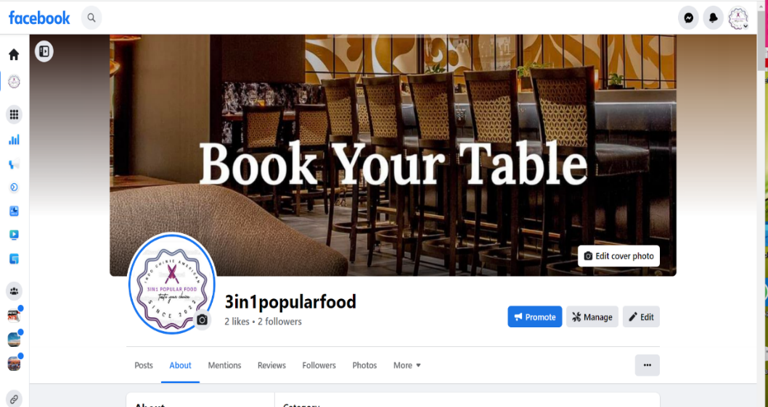

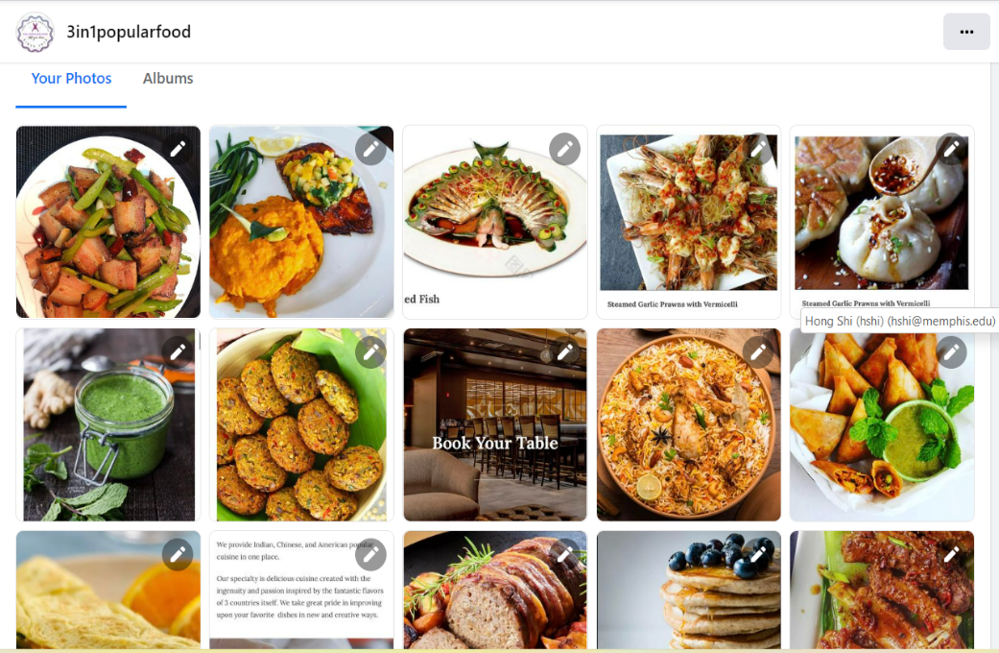

# **Why did we choose Facebook?**

We chose Facebook as one of our main social platforms, there are many reasons as below:

* Facebook is the largest social media platform globally with 2.85 billion monthly active users worldwide.
* 93% of marketers use Facebook, and 54% rank it as the most popular and influential social network for marketers.
* Facebook can help us to magnify our business brand awareness, find new customers, nurture customer loyalty, increase website traffic, improve sales, and enhance customer service.
* Facebook can make more people know about our business startup and catch them to put attention on our business.
* Facebook can post information about our business promotions easily and update them fast.
* Facebook can post word content, pictures, and videos frequently. We can choose the form of posting according to our business needs.

# **How Facebook fits in with our business strategy**

Facebook has a bigger audience on its platform than many other social media platforms. Most people who are around 20-38 years old (our target customers) will spend 6 to 8 hours on social media per day. Approximately 22% of the global population is utilizing Facebook. Facebook boasts approximately 2.01 billion monthly active users. We can post and update our business information such as promotions and introduce new dishes. We can create communities through Facebook for those who love food and cooking. Bring together people who share common interests to enhance our brand awareness and customer stickiness.

# **How we will use Facebook to promote our website and post frequently**

We will use Facebook to post these recipes featured on our website 4-5 times each week. It will help us to get more organic traffic to our website. We will continue to update all information, which includes the website URL, local address, working hours, special promotions, and specific holiday discounts. In addition, we will introduce updated products to keep our business competitive. We will respond to any message which comes from our website immediately. Our team keeps track of insights from the platform. The goal was to analyze the data and execute a well-planned marketing campaign.

# **Initial goals and KPI for Facebook**

Our Main goal was to drive traffic from social media to our website and Facebook has enabled us to achieve this. We hope to attract more and more people to our page on Facebook. Our goal is to reach 30 people who will follow our page, and one-third of those will click our website URL to get more information from 3in1popularfood.com. From the Insight of Facebook, the statistics show that our posting had reached 309 people and engaged 193 people on Facebook until now. Our team will keep posing frequently to grab more organic traffic.

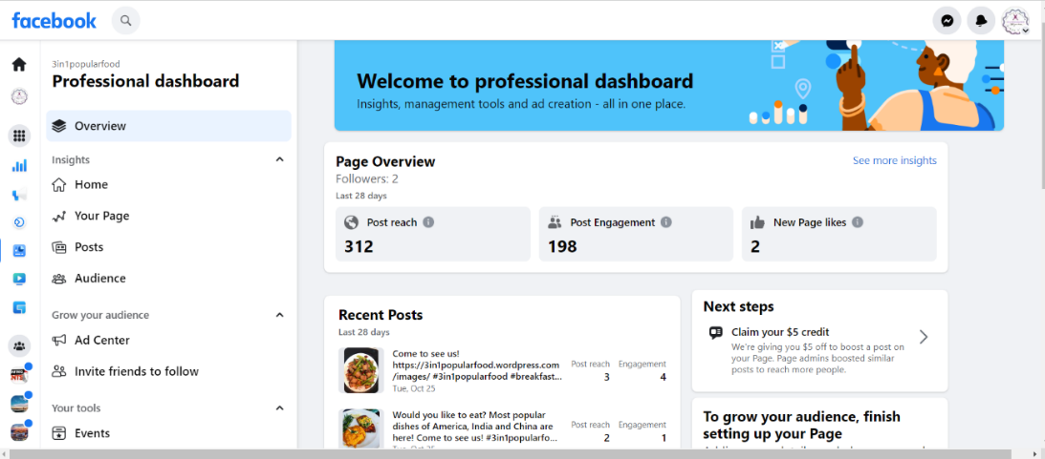

**Instagram strategy**

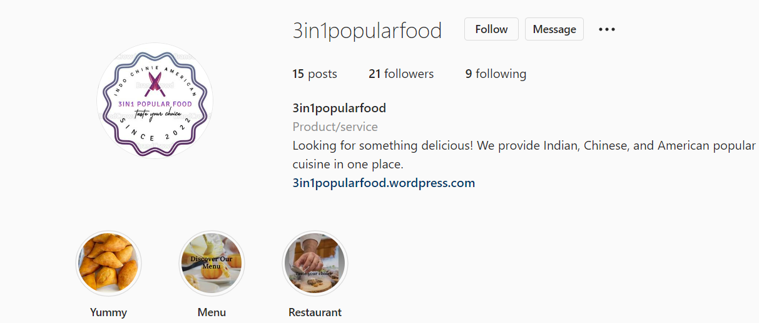

# **Why did we choose Instagram?**

We decided to use Instagram as the main social media platform to promote the website for the following reasons.

* Billions of people are using Instagram daily, so many people can be reached.
* The age group of people using Instagram is 18 and above making them the best target for our promotions.
* There is no limit to the number of followers you can have, and this can contribute to increasing the number that can be reached.
* With the introduction of Reels and hashtag combinations we can reach a greater audience and share different kinds of images and videos. With a single Reels and using the keywords as our hashtags for example ‘#Indian food near me, in the post, we reach many customers, and this will help our business to grow.

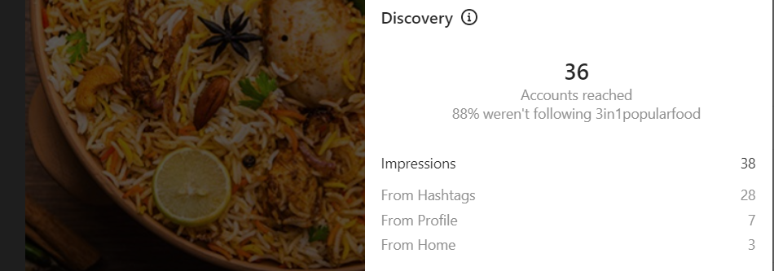

# **How Instagram fits in with our business strategy**

There is a diverse population of users globally that are consistently using Instagram twenty-four hours a day. With Instagram, we can reach different age groups, varying ethnic groups, and demographics. The platform has enabled us to share our ideas, connect and reach our target audience. This fits in with our business strategy to reach and attract and keep in touch with our target audience.

Using Instagram drives brand awareness, boosts sales, and builds and tracks audience engagement. It's an excellent way to find customers where they're already spending time. It can also provide valuable audience insights to use with all the marketing plan strategies.

# **How we will use Instagram to promote our website and post frequently**

Our team decided to post at least 5 times a week on social media sites consistently. This way we will increase traffic to the website. The idea is to be consistent with posting and keep our followers engaged.

We updated all the required additional information like Website URL, Email address, and working hours strategically. For a start, we determine the best day to post in the early hours so that it can get user attention immediately after they open their page. We will continue posting images and videos about our dishes, our recipes, and all information relating to 3in1popular food. We intend to post informative ideas to help our customers locate our sites. We keep track of insight into the platform. The goal was to analyze the data and execute the Idea of well-planned marketing.

We have different types of posts ranging from page posts, stories, and videos posted as Reels. In an Instagram story for example we add links to our story using Instagram link stickers and such links can be accessed by everyone.

# **Initial goals and KPI for Instagram**

Our Main goal was to drive traffic from social media to our website and Instagram has enabled us to achieve this.

From Insight, the statistics show that we are getting a great response as the page views have increased to 30% since opening the page. The goal of opening the page was to reach out to the maximum number of people. According to the insight, the followers, and likes are an indication that people are reaching our pages.

# **Blogging strategy**

Blog Marketing is a content marketing strategy. The marketing strategy uses blogs to address potential customers directly and individually, thus achieving customer loyalty for the brand. This type of marketing uses viral marketing methods in which an interest group is built based on a blog.

Our home blog design is the first thing people see. It’s also the most distinguishable feature of our blog. And we have expressed all the information about what the business stands for.

The menu blogs are organized into 3 categories: Indian, Chines, and American. Each menu blog has appropriate tags to ensure good promotion and navigation on the website. We plan to post 2 new blogs or recipes each week to introduce new recipes, keep our content fresh, and promote our products to site visitors.

# **Inbound Link Strategy**

To make our website more authoritative, we will choose to make some inbound links from some high-quality, highly relevant, and related websites that already have a certain degree of authority, which can help visitors to find us better. According to our business goal, we will set up some relative google alert content to help us to get these highest quality and relative contents and events quickly and freshly. According to the results of google alert, we can follow current popular events best, and set some proper anchor text inbound links which can link back to [www.3in1popularfood.com](http://www.3in1popularfood.com) or relate dishes page in our blogs. This will help our website increase visibility. And, according to our social media strategy. We will add our website URL (using the shorter URLs) in all postings on Facebook, Instagram, and Blog. All visitors can use it to link back to our website or some specific dishes. We only need to keep our postings of high quality and high frequency to gain more traffic.

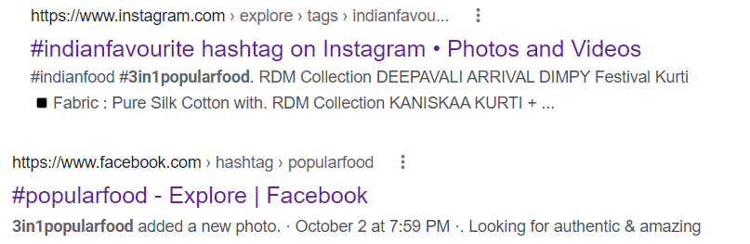

Concentrating on social media because we are noticing an endless stream of comments at the end of each post. This is because we created content that builds relationships with readers. Almost all the posts end with a question for the reader to comment on. And use a commenting system, which also integrates social media and accounts.

They can drive traffic to our website**.** If someone posts a backlink to your website on their website or blog, their readers might click on it, and we will benefit from that referral traffic.

They can help us rank higher in search. Backlinks tell search engines that your website is an authority on a certain subject — so the more backlinks you earn from high-quality, [high-authority sites](https://dofollow.io/blog/increase-domain-authority), the better your website will rank in search engine results pages (SERPs).

A blog is meant to be a social tool. The more we link to others — especially when we do it in a consistent, opportunity-driven way — the greater likelihood that one of those bloggers will return the favor. Plus, we can't cover everything about everything on our blog. It makes sense to leverage the wealth of resources on the web to make your blog's experience better and more rewarding for your readers. Our web page links to your social media pages and vice versa.

Instagram: <https://www.instagram.com/3in1popularfood/?igshid=YmMyMTA2M2Y%3D>

Facebook: <https://www.facebook.com/people/3in1popularfood/100086522437073/>

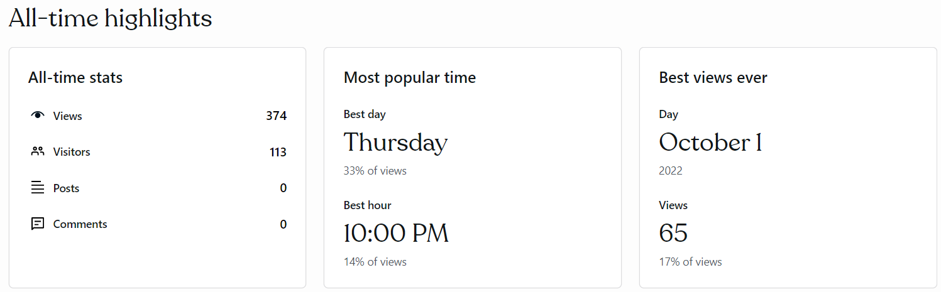

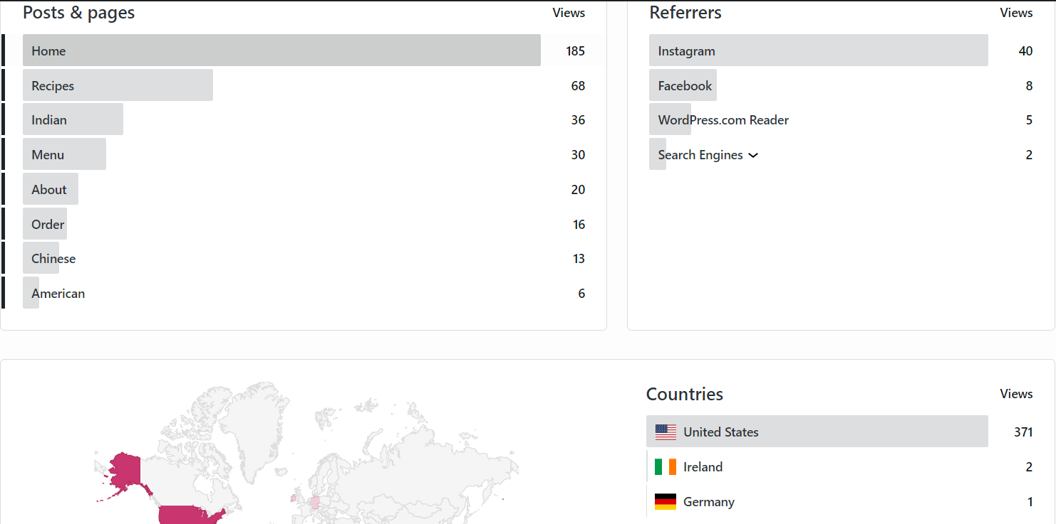

We can see the number of views in our blog. So, we will get to know we have more viewers on Instagram compared to Facebook. We will concentrate our marketing strategy more on Instagram. There is a world map in which we can see which country is most interested in our popular food. More viewers from the United States.

Above screenshot from the web page. We have 370 users who visited our web page. Analyzing the data of the visitors will improve our business.

**Email Campaign**

It enables people who have an interest in an organization to subscribe to their emails using sign-up forms on websites. We used MailChimp to create and design our newsletter and send it to our audience to help market our services and to increase web traffic, that was our initial Marketing strategy.

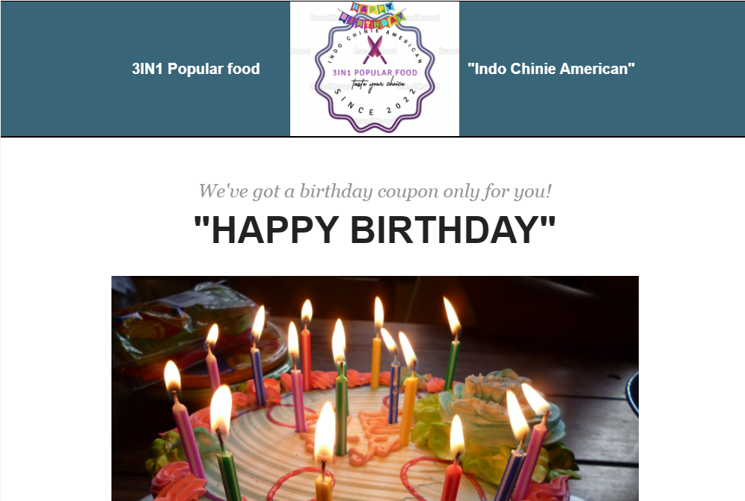

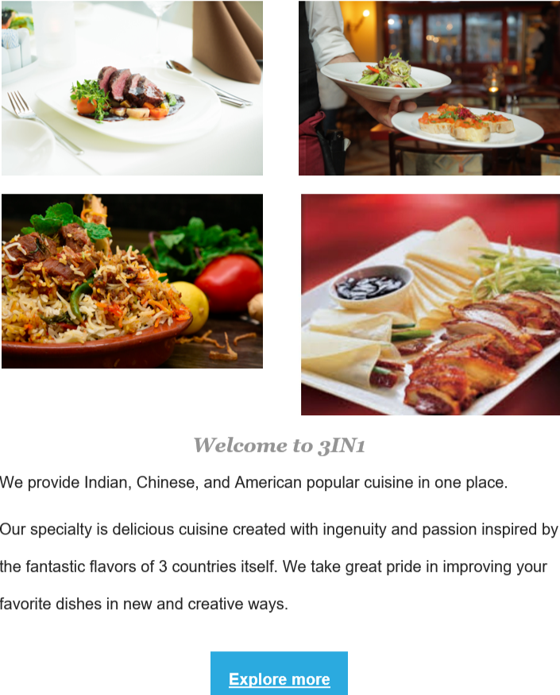

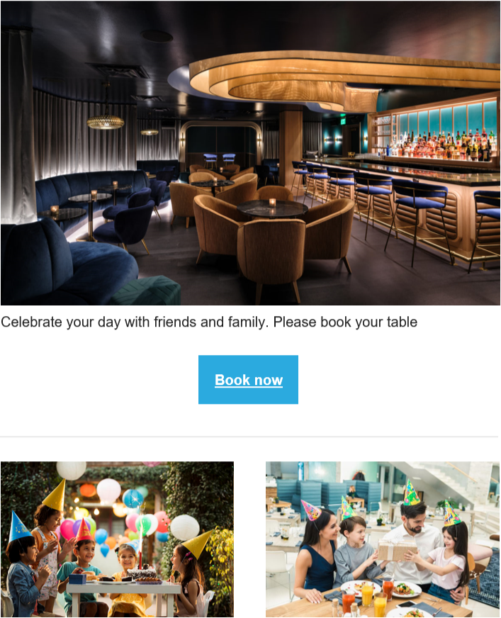

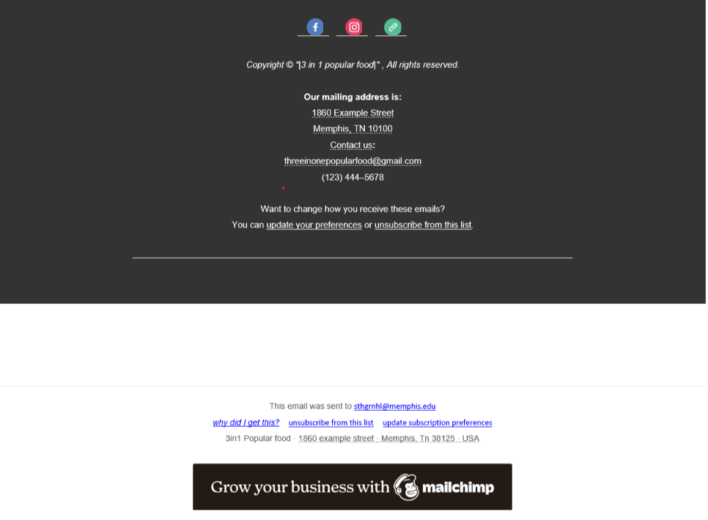

We chose the design and templates which suit our newsletter content. We connected MailChimp with WordPress for analysis. We used UTM builder to create new URLs and link them in the newsletter. We used call-to-action buttons such as “Book now,” “Explore more,” and “found out more.” All these connect to our main website with an increasing number of clicks and people reaching our business. Before sending the newsletter, we tested it with a few personal emails.

We also provided the unsubscribe button option in our newsletter to give them the freedom of unsubscribing. In our list, we have 45 subscribers, and we sent the newsletter to all of them. To encourage users to explore more of our content, we have added social media buttons to our newsletters.  The purpose of sending out newsletters to our subscribers or users is to increase traffic to our website and this has been shown through our MailChimp page analysis.

**Mailchimp Analysis**

The email was eventually sent to our list of subscribers on the 13th of November in the evening when most people would be home and free to browse through their emails. The Newsletter was also shared on our social media platforms. We sent the newsletter to all subscribers and the delivery rate was 100% successful.

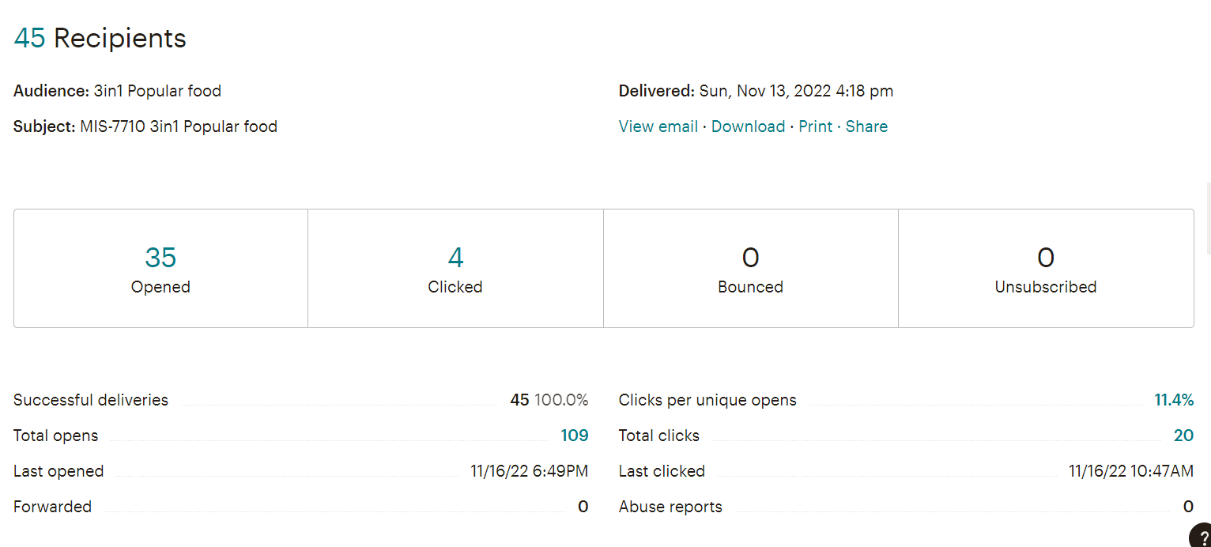

The 3in1popular food birthday newsletter had a 35 open rate and 4 click rate.

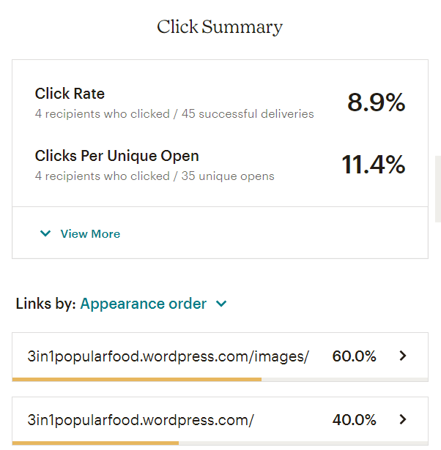

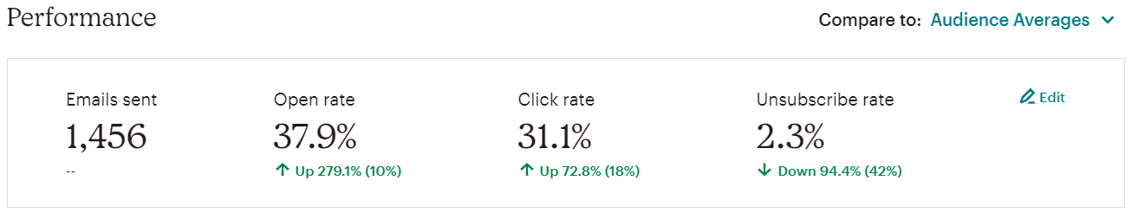

Only 8.9% of openers click the link. 60% of them click the “3in1popularfood.wordpress.com/images/”, and another 40% click the “3in1popularfood.wordpress.com/”.

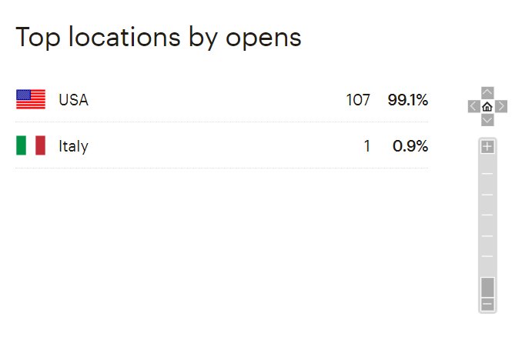

99.1% of openers are from the USA, and only 0.9% of them are from Italy. None of them are from other countries.

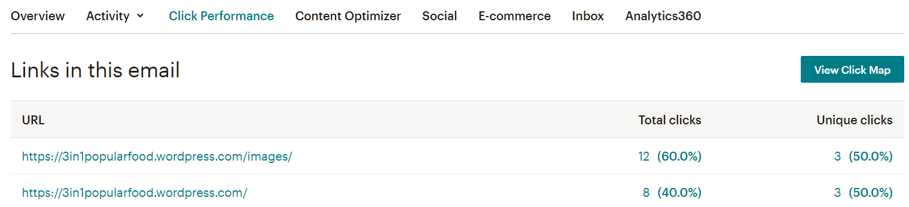

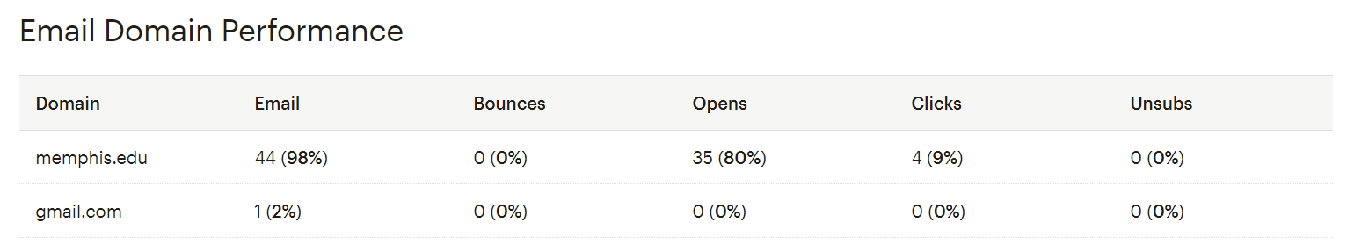

Mailchimp report showed a 24-hour performance and activities. The delivery time worked for us. In the report, we saw there were 35 open impressions and 4 clicked impressions between 7 PM to 9 PM. It was great, opening within one and a half hours. We decided to stick to the same time for future newsletters. Above is the data about the links which were clicked to prove that they worked perfectly. The most clicked URL was the home page of the website.

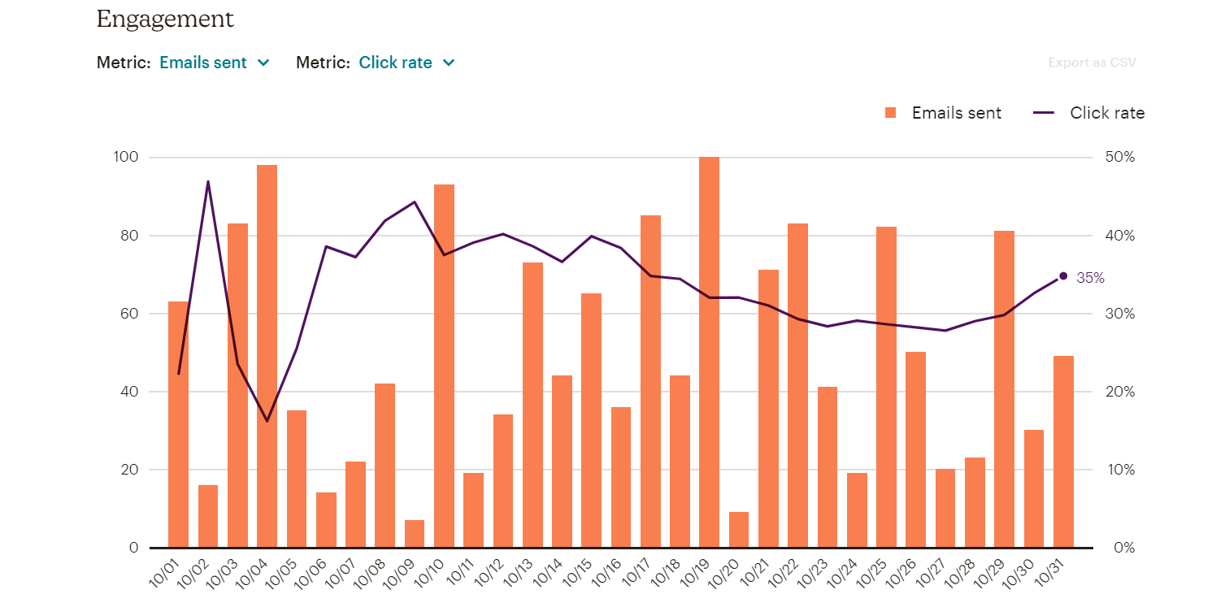

**Social media**

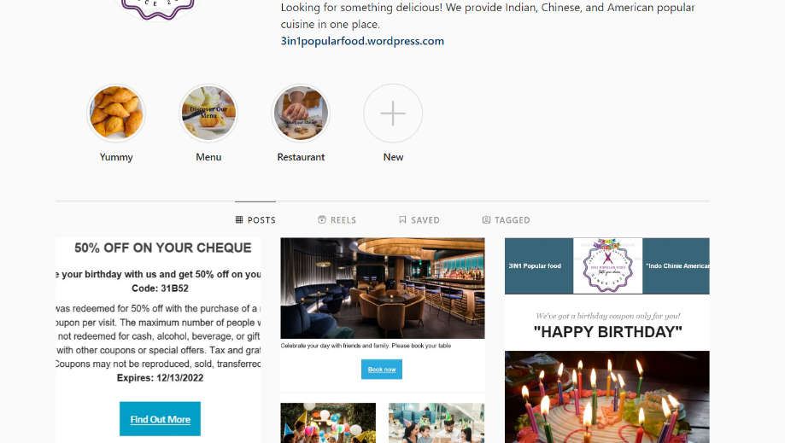

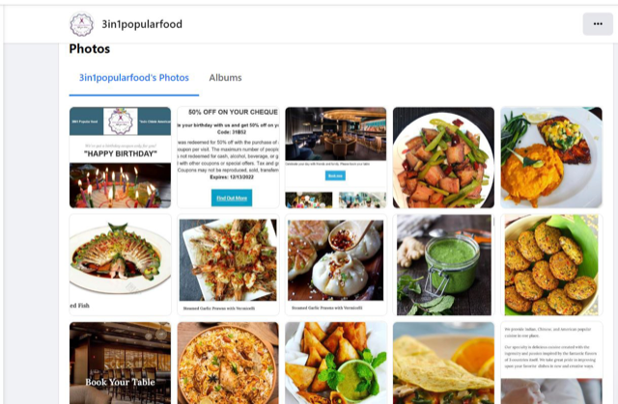

We have advertised our weekly newsletter on all the social media platforms to attract users. It is one of our marketing strategies, we have added our website link to that attachment when users click on the newsletter it directs them to the website and they can sign up for us for the future exciting newsletter.

**Sign-up form**

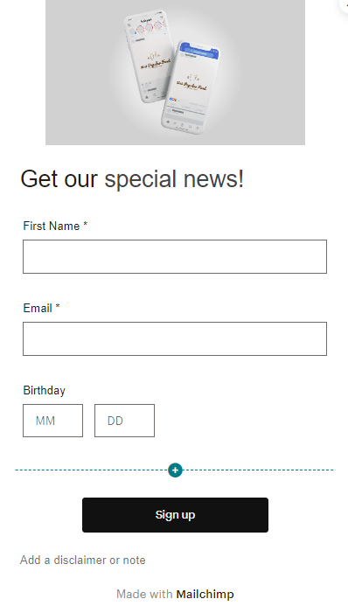

An important part of growing our customer list is to invite visitors to sign up for our newsletter from the website. To link your website to Mailchimp.

We have created the signup form in the mail chimp and connected it to the web page so that users can sign up on our web page to get exciting offers, discounts, etc. Mainly email marketing helps us to send an every-week newsletter to signed-up customers.

**Insights Summary**

* Our social media campaign was driving in most of the traffic.
* Our email campaign led to the highest conversions.
* Homepage was the landing page for most of the users.
* Desktop users are more for websites.
* Newsletter subscriptions usually happen 3 to 4 days after the email is sent out.
* Most of our users are from the USA as we planned.

**Improvements**

* Improve our Homepage structure to decrease bounce rate.
* Increase Social media posts on (Monday, Tuesday, Wednesday) to drive in more traffic
* Add more inventory to 3 IN 1 menu. This helps in overcoming the huge   
  drop out analyzed in behavior flow.

**Goal of the Project**

* Providing more quality content on websites.
* Regularly adding new information, establishing trust, and marketing your site on other websites and social media.
* Providing good user experience and helping our website visitors access and navigate your website with ease.
* Drive more traffic, engage prospects, generate leads, and re-engage existing customers.

**Reference**

Bhasin, H. (2019, March 1). *The difference between google vs Facebook: The brand fight between 2 Top Internet Brands*. Marketing91. Retrieved October 26, 2022, from <https://www.marketing91.com/google-vs-facebook/>

Wikimedia Foundation. (2022, October 26). *Social Media*. Wikipedia. Retrieved October 26, 2022, from <https://en.wikipedia.org/wiki/Social_media>

By. (n.d.). *How to track social media traffic using google analytics*. Social Media Examiner. Retrieved October 27, 2022, from <https://www.socialmediaexaminer.com/track-social-media-traffic-google-analytics/>